**Mainframes DXC Australia**

**Assessment 5: JCL, VSAM, & CICS**

**By: Pranay Yara**

**2/08/2024**

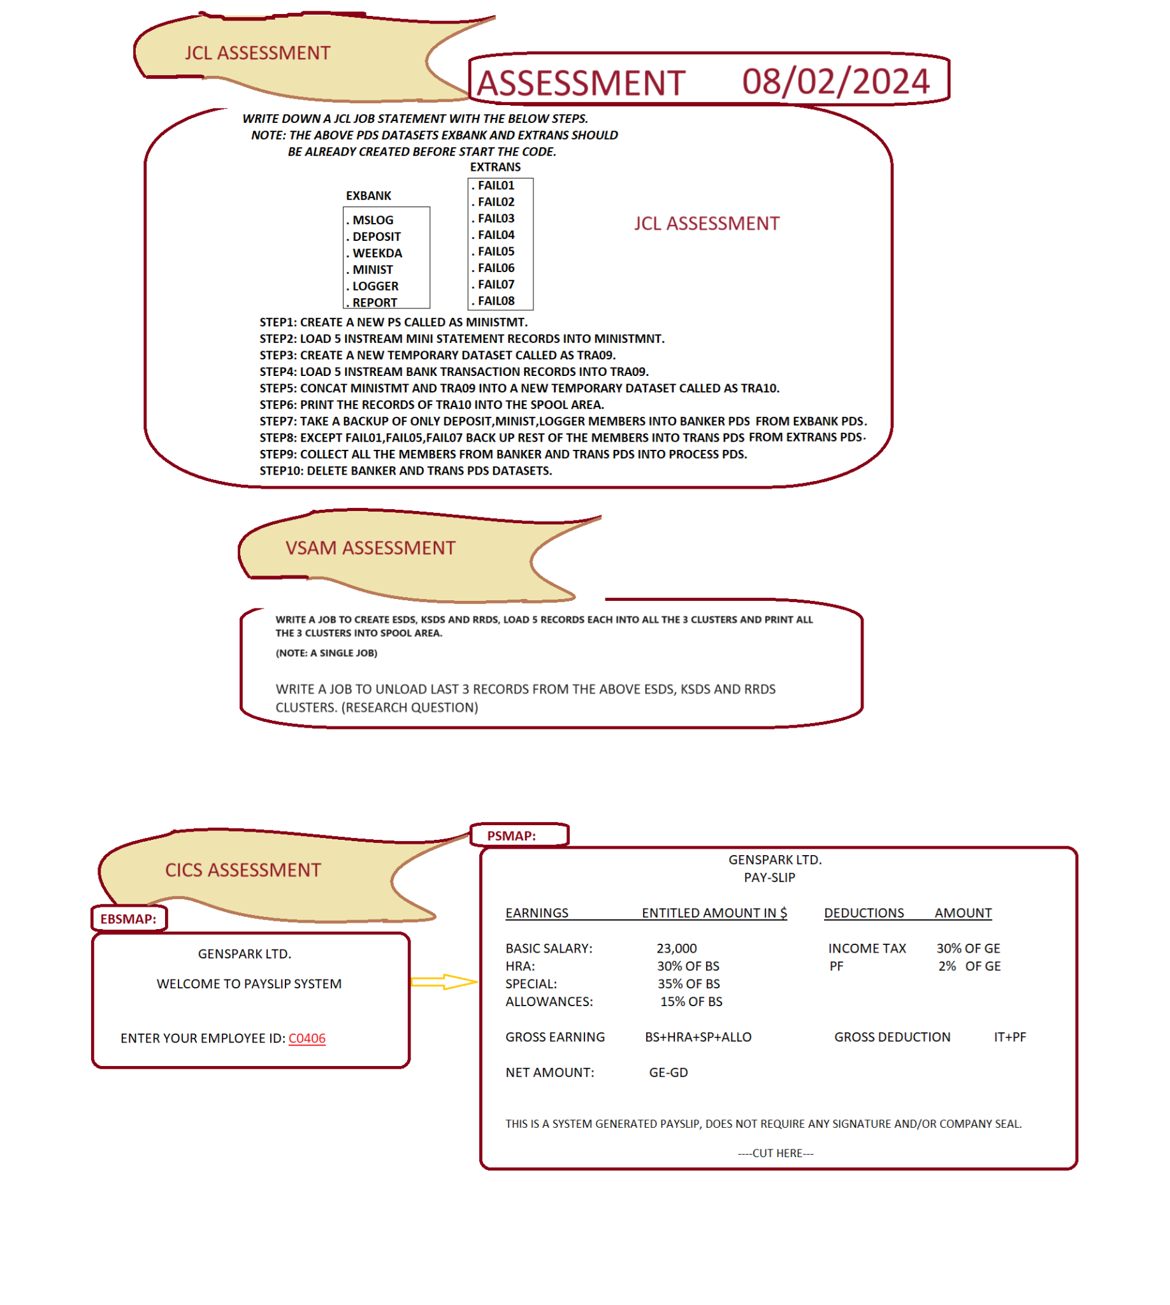

**JCL ASSESSMENT**

**Comments**: Overall, I completed all the steps without any difficulty. I used the restart parameter and did the steps one by one to show outputs of each step clearly. At step 9 was the only error I received - it was maxcc 0008 which means syntax error and when I checked the spool it said “CONCATENATED DATA SETS NOT ALLOWED. USE MULTIPLE INDD= OPERANDS.” So, with that clue I was able to resolve the error on my next submission.

**Prerequisite**:

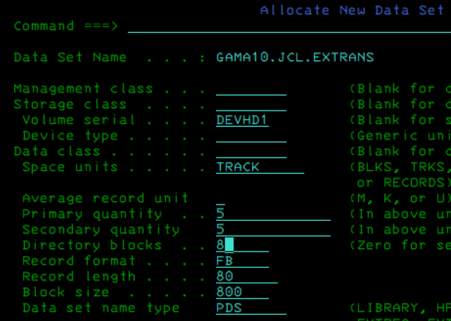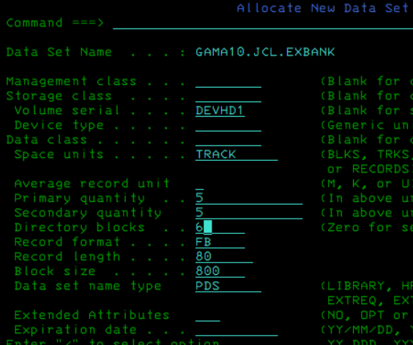

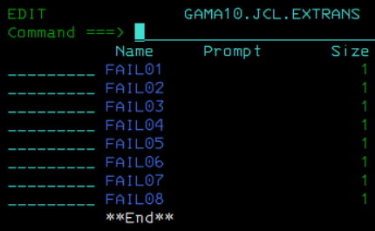

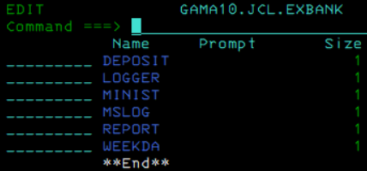

**STEP 1:**

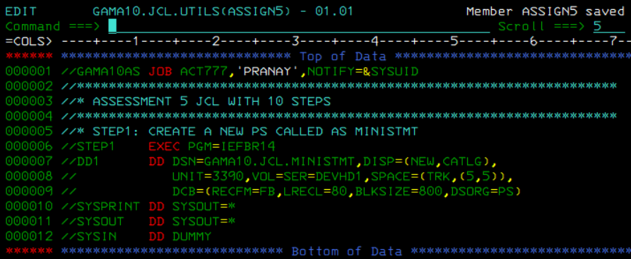

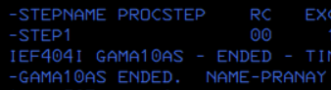

**STEP 2:**

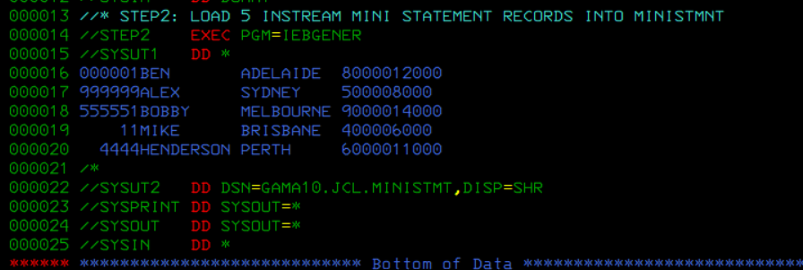

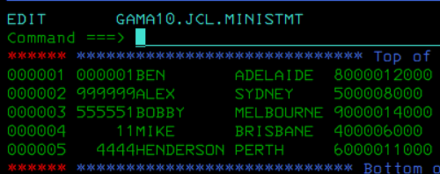

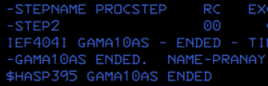

**STEP 3 & STEP 4:**

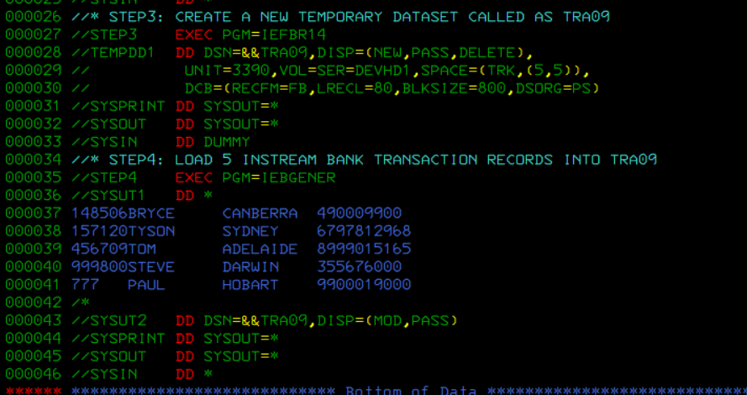

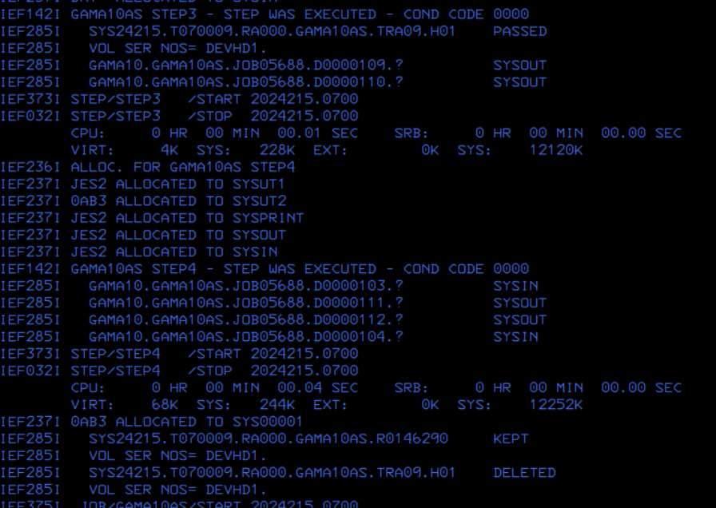

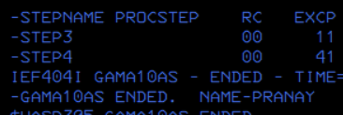



**STEP 5 & STEP 6:**

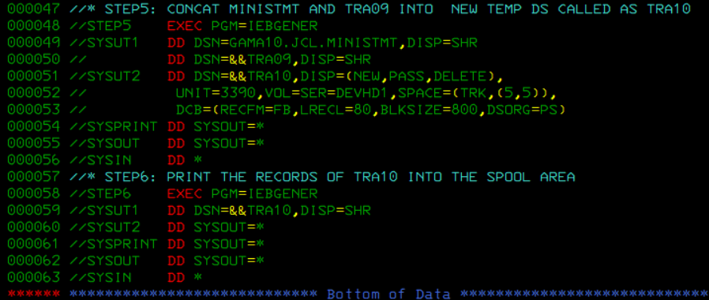

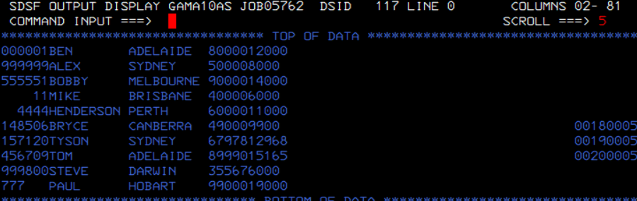

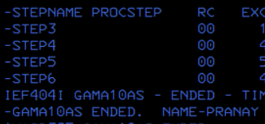

**STEP 7 & STEP 8:**

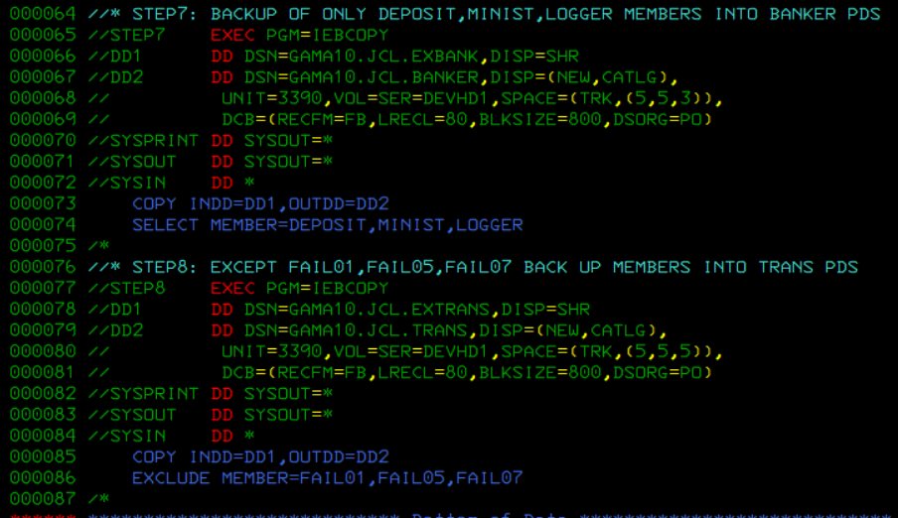

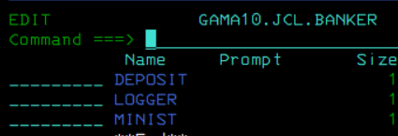

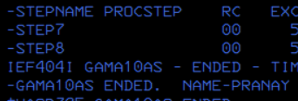

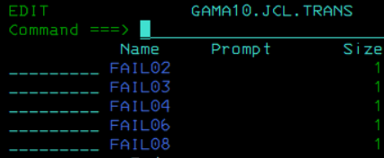

**STEP 9:**

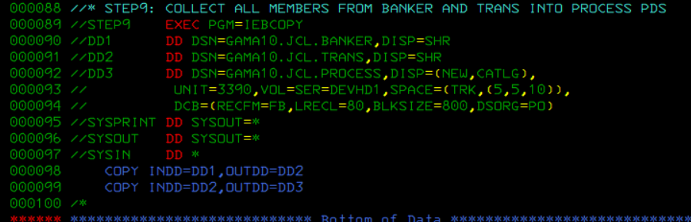

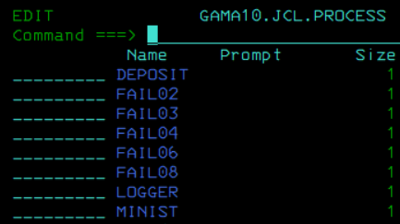

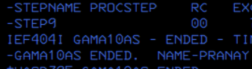

**STEP 10:**

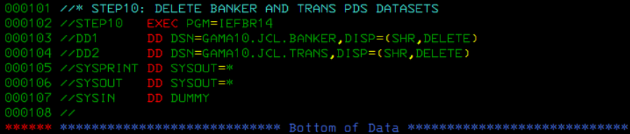

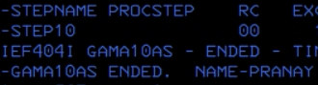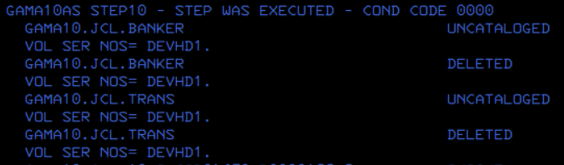

**VSAM ASSESSMENT**

**Comments**: As advised, I completed this in 9 steps - to avoid any complexities. I also didn’t encounter any errors. Also, when I created the rrds - from my understanding because the rrds only allows fixed length records, I didn’t use any free space. Whereas, freespace for ksds or esds is allowed because its records can also be variable length records.

**STEP 1, STEP 2 & STEP 3:**

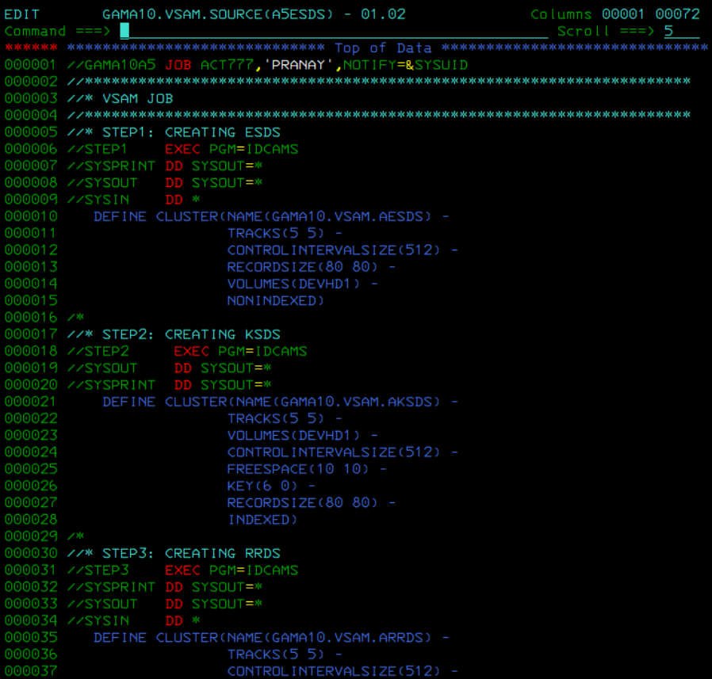

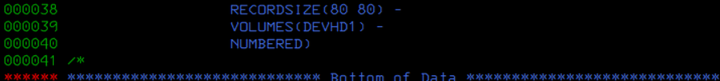

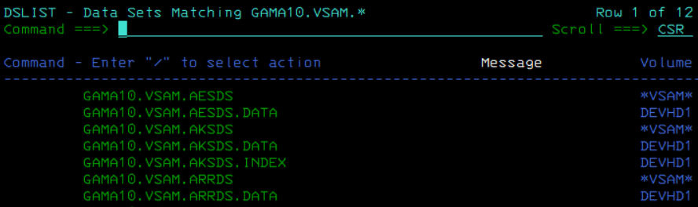

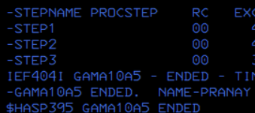

**STEP 4, STEP 5 & STEP 6:**

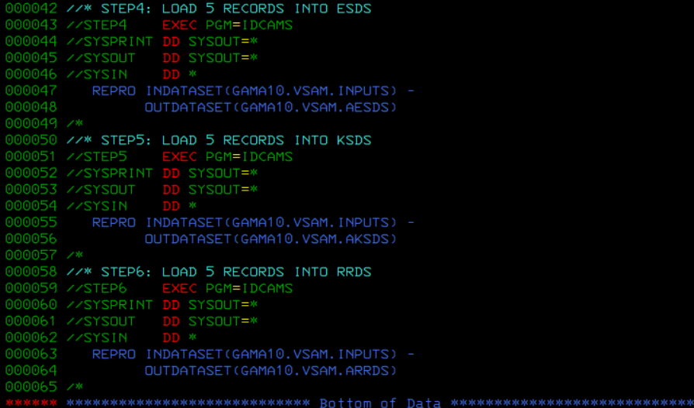

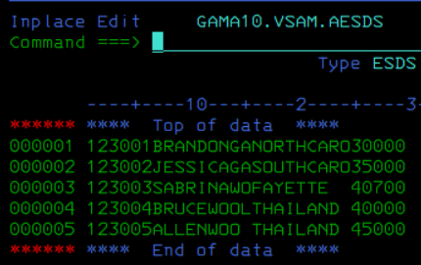



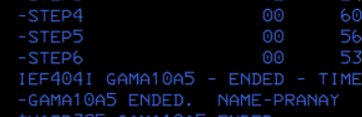

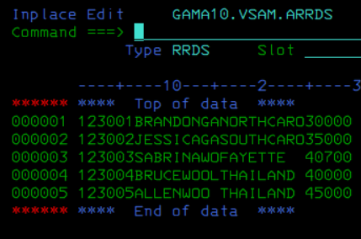

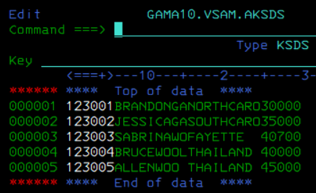

**Note:**

For this step, I have used a previously created input dataset. If you want to use instream data you can use a dd statement and infile instead of indataset. Also, there are many ways to view a vsam dataset: spool, tso command in catalog, file manager, or ditto.

**STEP 7, STEP 8 & STEP 9:**

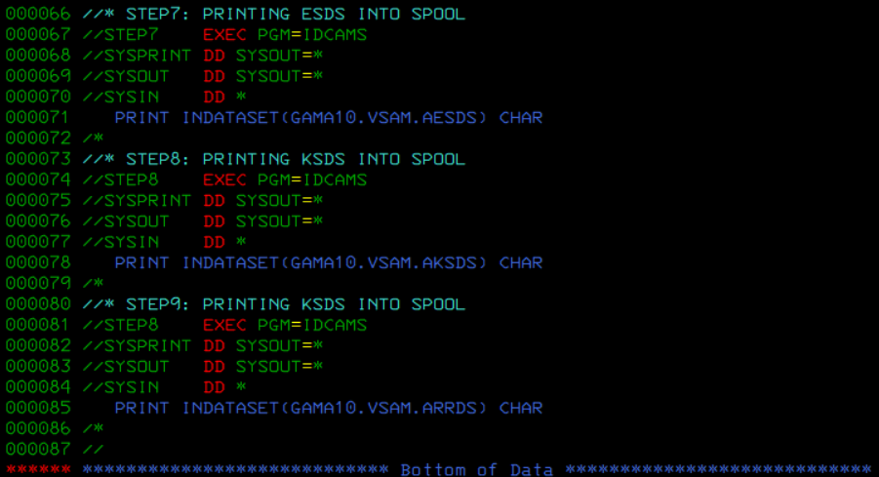

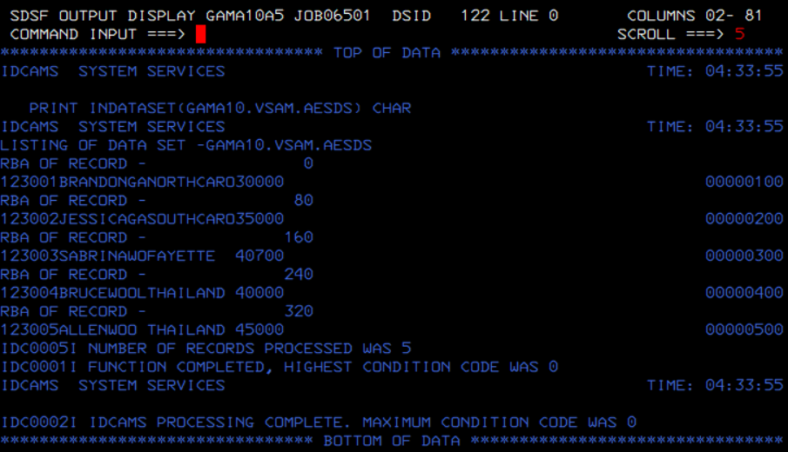

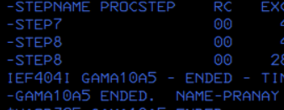

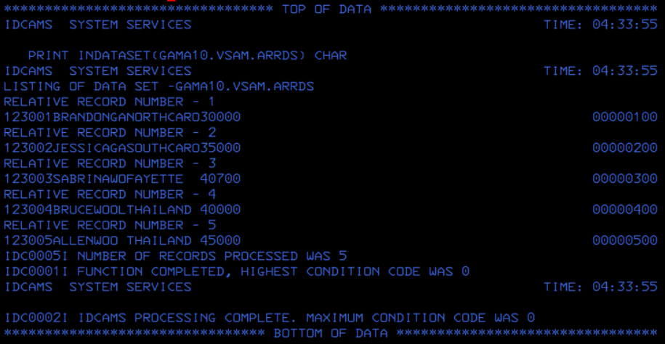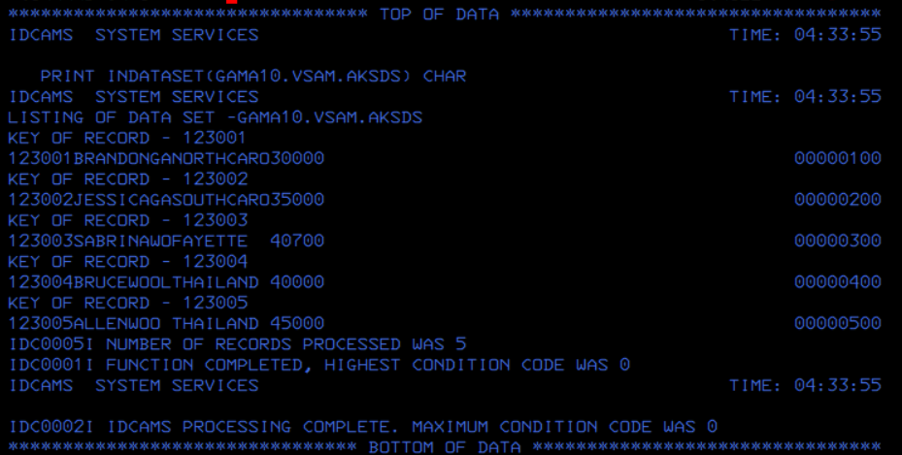

**Research Question:** I know I can do this in three steps but I wanted to try in one step.

**Comments**: For this question, I knew from classes you have to use FROMADDRESS and TOADDRESS for esds. I then looked at the spool prints for any hints and with some additional research I found that I can use FROMKEY and TOKEY for ksds and FROMNUMBER and TONUMBER for rrds.

Moreover, I did initially use OUTADDRESS for esds but I kept getting max cc 04 warning even though the last 3 records were copied. Also, it was only for this dataset, not for my ksds and rrds. I wanted to have max cc 0. So, I was thinking about boundaries and because 320 is the last address, I removed the outaddress to specify every address after 160 which still gives the last three records.

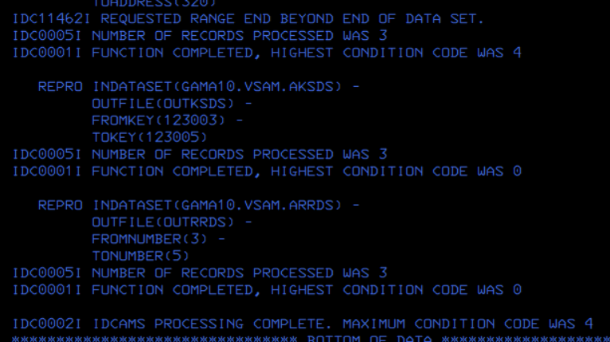

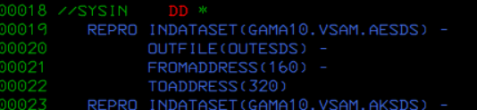

**Step:**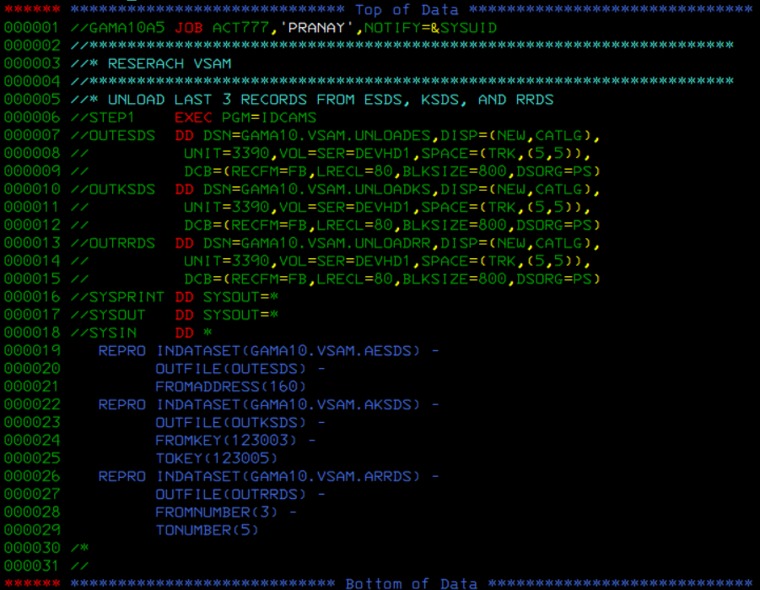

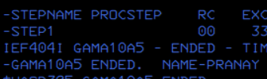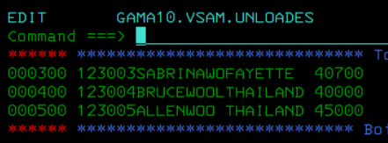

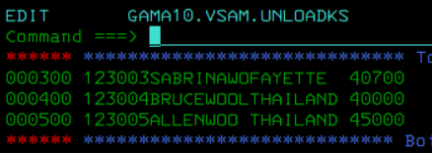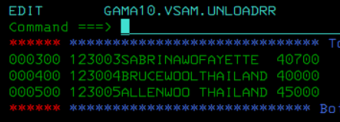

**CICS ASSESSMENT**

**Comments**: I was facing max cc 12 error with the cobol program, I tried debugging and testing parts of code but still I was getting max cc 12 error where there was filler three times for SALO. In the end after two days of failed debugging, I re-did the entire program and bms from scratch making sure i was testing after every variable and this strategy ended up working. However, once I was in cics trying to print I kept getting ABEND. After research, I was able to find out, the map size has to be 24,80 because that's what my terminal supports.

**BSM:** 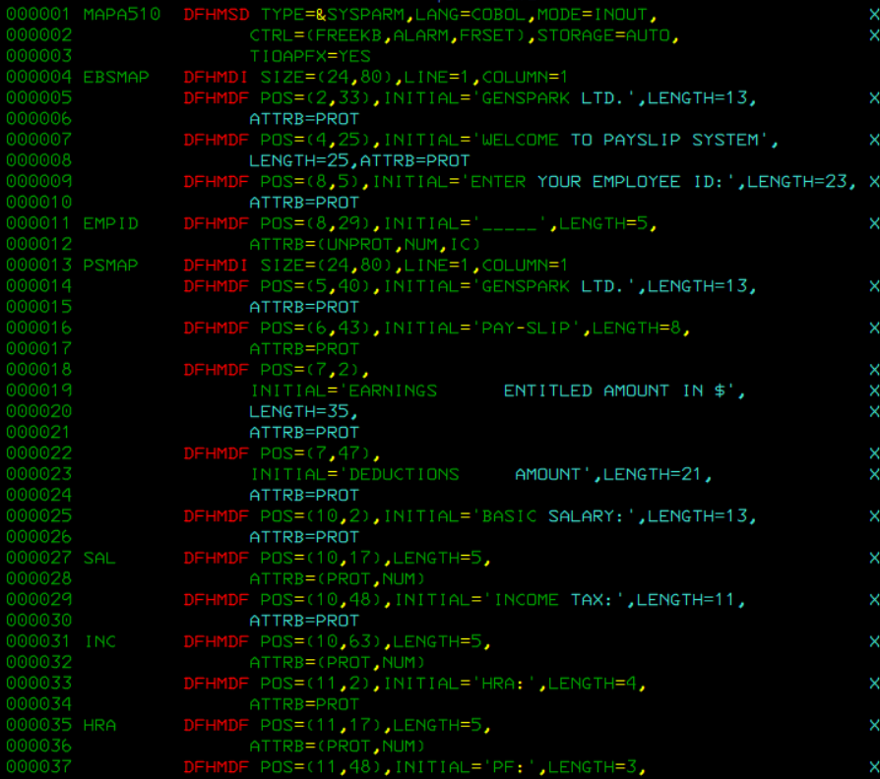

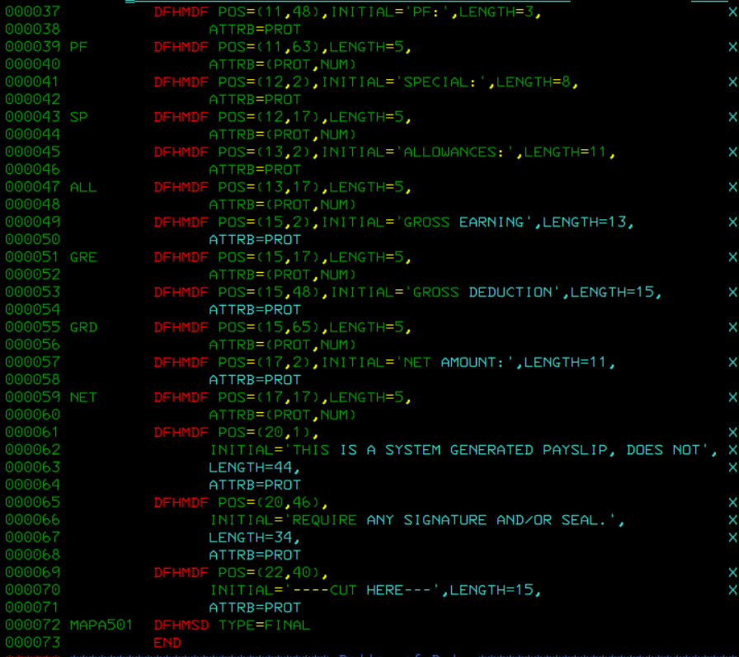

**COBOL Program:**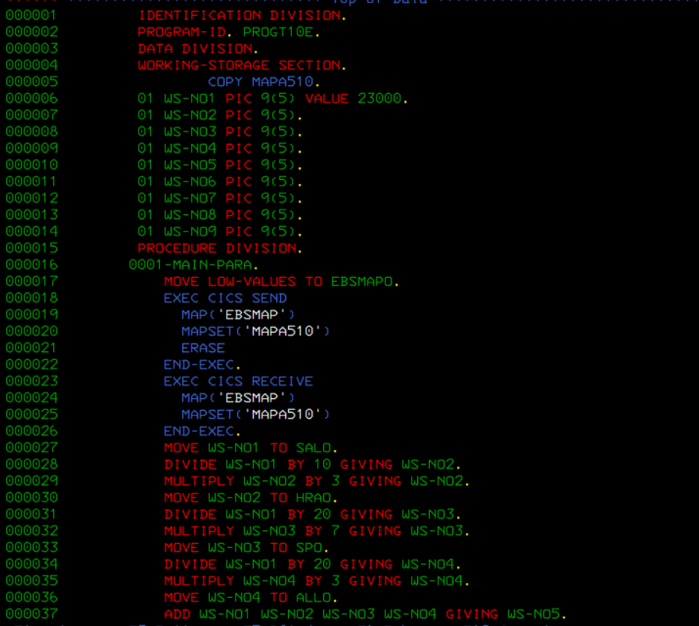

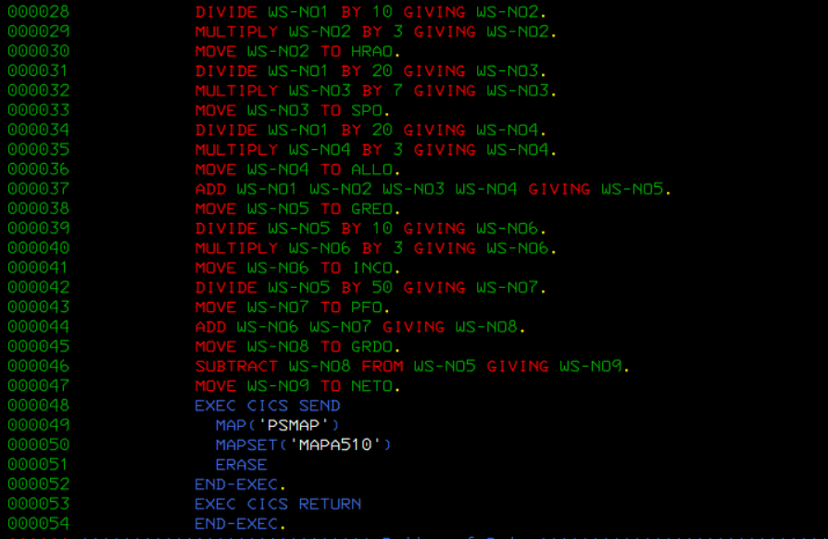

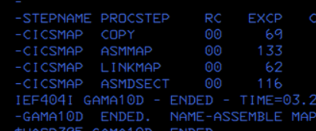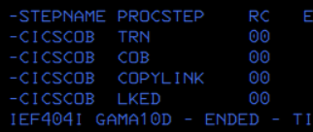

**Define in CICS:**

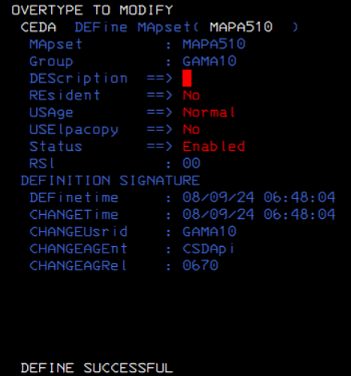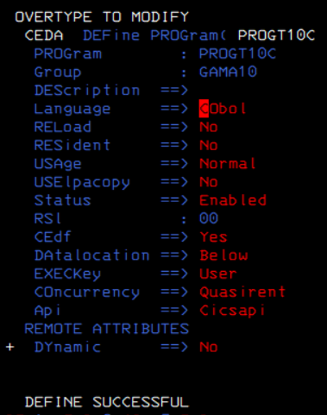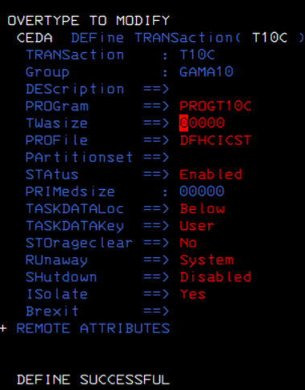

**Installation in CICS:**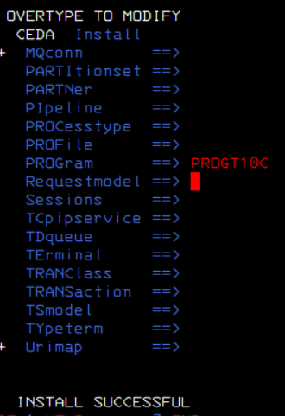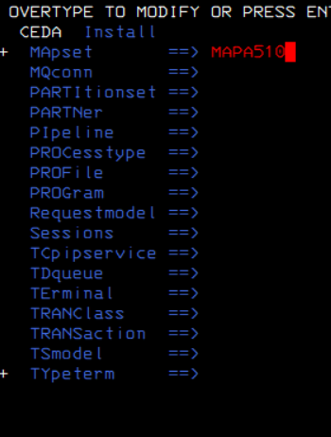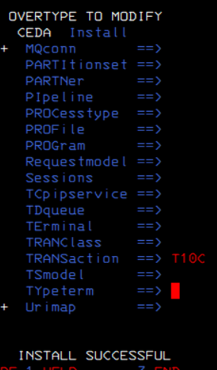

**Printing:**